**Wave dump using digitizer component**

**Abstract**

The digitizer block in SciCompiler works as a programmable size FIFO to store waveform. It is possible to define, compiling time, the maximum number of channels, while at runtime it is possible to select which channels effectively dump.

In respect to the oscilloscope, this modules allows a faster way to dump waveform and have the possibility to partition the total amount of samples in the FIFO on multiple channels.

**1 Structure of the digitizer block**

The digitizer block is designed as following: a packet creator block serializes the enabled channels in a common FIFO and transfer data to the PC.

Every time a start signal is triggered, the timestamp, the hits and user data are captured, and enqueued in the output FIFO.

The packet creator is designed to optimize the usage of the output FIFO. It is possible to select the number of channels to download a runtime in order to do no waste FIFO area on not used channels.

It is only possible the specify the number of channels (N) starting from the channel 0. So If N = 2, CH0 and CH1 will be dumped, if N = 4, CH0, CH1, CH2, CH3 will be dumped.

Four channel data acquisition

Single channel data acquisition

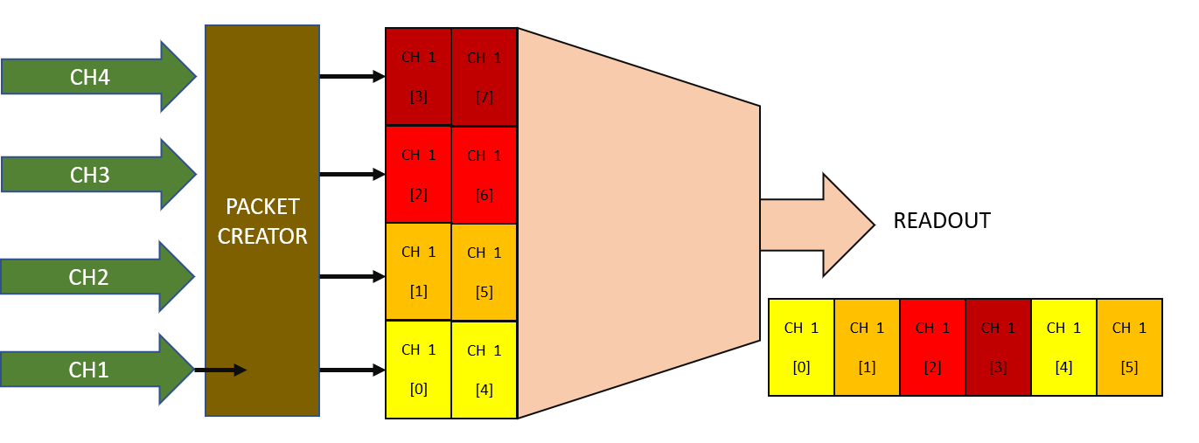

**2 Digitizer component**

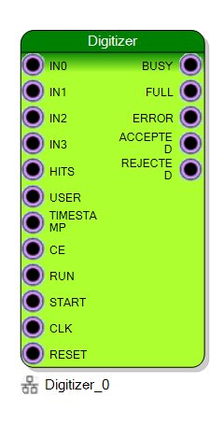

|  |  |  |
| --- | --- | --- |
| **IN** |  | Size: 16 |

*Waveform data, one for each channel enabled*

|  |  |  |
| --- | --- | --- |
| **HITS** |  | Size: 64 |

*General purpose 64bit register. Typically used to store which channels fired the trigger, but can be used for any other indication. It is captured on the rising edge of the start*

|  |  |  |
| --- | --- | --- |
| **USER** |  | Size: 32 |

*General purpose 32bit register. It is captured on the rising edge of the start*

|  |  |  |
| --- | --- | --- |
| **TIMESTAMP** |  | Size: 64 |

*Connect to the board or system timestamp generator in order to synchronize acquisition to a global timing*

|  |  |  |
| --- | --- | --- |
| **CE** |  | Size: 1 |

*Enable data point storage*

|  |  |  |
| --- | --- | --- |
| **START** |  | Size: 1 |

*Input signal enabling the digitization process*

|  |  |  |
| --- | --- | --- |
| **BUSY** |  | Size: 1 |

*Output signal indicating when HIGH that the digitization process is occurring*

|  |  |  |
| --- | --- | --- |
| **FULL** |  | Size: 1 |

*Output signal indicating when HIGH that the internal memory is full and can not acquire other waveform*

|  |  |  |
| --- | --- | --- |
| **ERROR** |  | Size: 1 |

*Settings are not compliant to the configuration*

|  |  |  |
| --- | --- | --- |
| **ACCEPTED** |  | Size: 1 |

*Last START has been accepted by the digitizer block and the full waveform will be captured and transmitted*

|  |  |  |
| --- | --- | --- |
| **REJECTED** |  | Size: 1 |

*Last START has been rejected*

**3 Example design**

In the following example the digitizer is configured to acquire 16 bits analog data from 4 channels. Timestamp, hits, and user data are not connected indeed they will be zero. Run is fixed to TRUE, while the start is triggered by the pulse generator with a programmable period.

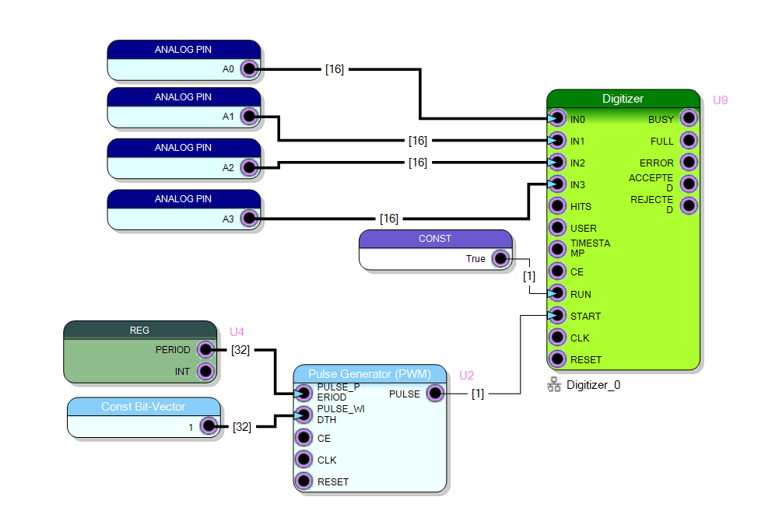

**3 Data acquisition using Resource Explorer**

In the following example the digitizer is configured to acquire 16 bit analog data from 4 channels.

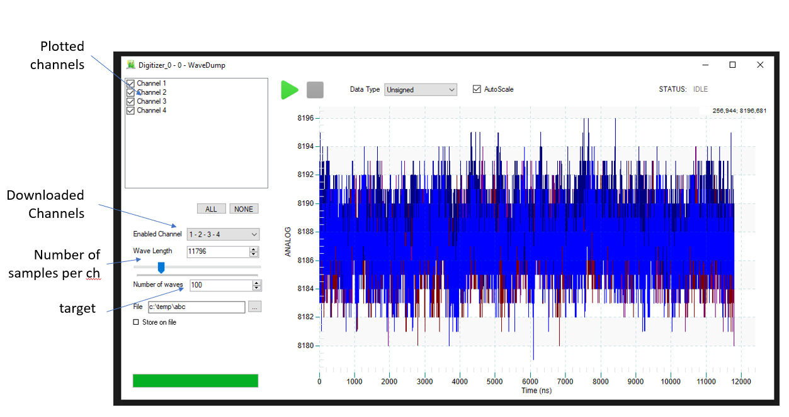

**4 Data acquisition using C++**

//How many waves acquire (20)

uint32_t TargetWaveNumber = 20;

//Enable channels 1,2,3,4

uint32_t ChannelsEnable = 4;

//How many samples per wave (1000)

uint32_t WaveformLen = 4000;

size_list = (ChannelsEnable*WaveformLen + 10);

data_list = malloc(size_list * sizeof(uint32_t));

TargetDataNumber = size_list * TargetWaveNumber/2;

R_Init();

if(R_ConnectDevice(BOARD_IP_ADDRESS, 8888, &handle) != 0) { printf("Unable to connect to the board!\n"); return (-1); };

//Se the pulse generator to generate 1 pulse every 10000 clock cycles

REG_PERIOD_SET(10000, &handle);

//Set Digitizer wave Len

LISTMODULE_Digitizer_0_SetLen(&handle, WaveformLen);

//Set Digitizer enabled channels and start acquisition

LISTMODULE_Digitizer_0_START(&handle, ChannelsEnable);

//Dump Data and write on file

fopen_s(&fp,"c:\\temp\\data.hex", "wb");

printf("Start download\n");

while (TargetDataNumber > 0) {

if (LISTMODULE_Digitizer_0_DOWNLOAD(data_list, size_list, timeout_list, &handle, &read_data_list, &valid_data_list) != 0) printf("Get Data Error");

if (valid_data_list > 0) {

fwrite(data_list, 4, valid_data_list, fp);

printf("."); fflush(stdout);

}

TargetDataNumber -= valid_data_list;

}

fclose(fp);

**5 RAW data format**

The file dumped from the script above will save the file as a list of events. Every event is triggered by a L->H commutation of the START input.

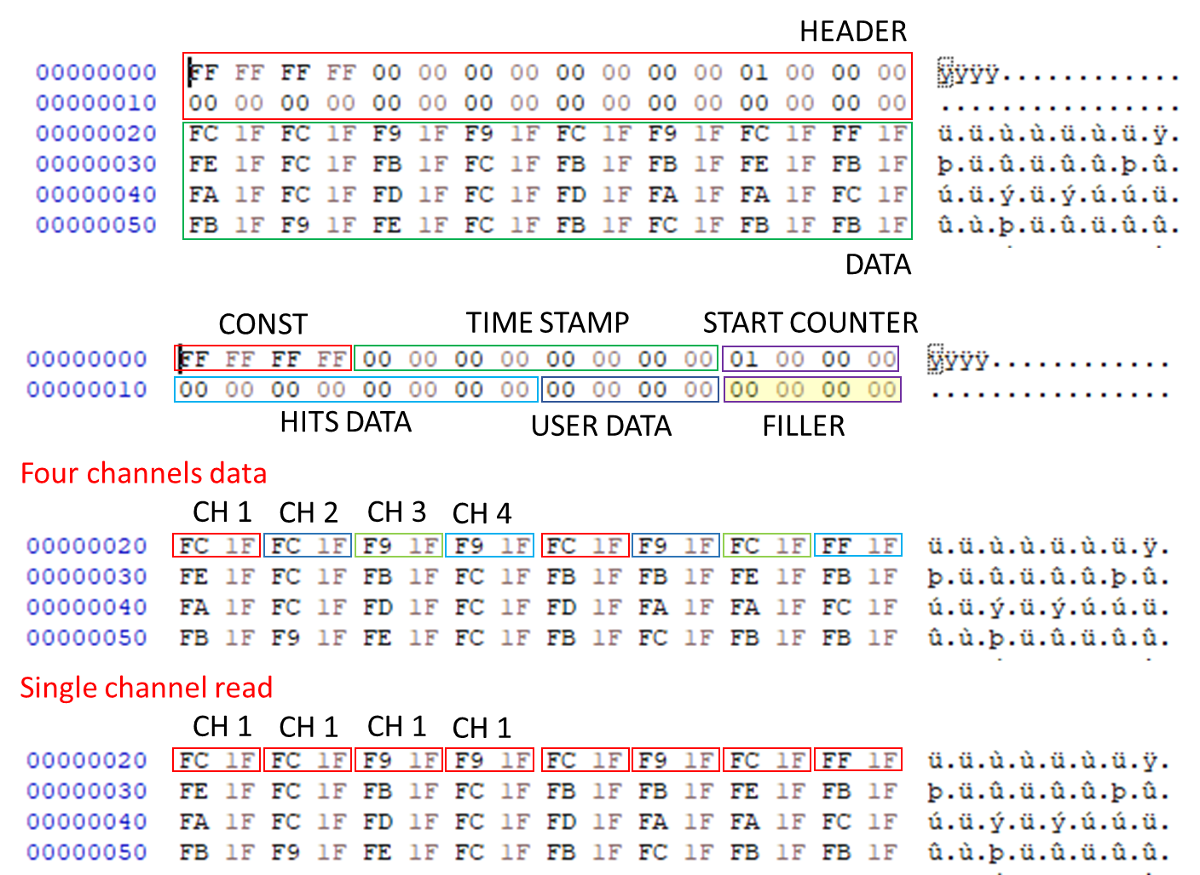

FILLER

The filler field size is variable and depends on the MAXIMUM number of channels selected at compiling time and does not depends by the effective number of channels configured to be readout. If in SciCompiler you configure the Digitizer to have four input, the filler will be 1 independently from what is set by the API LISTMODULE_Digitizer_0_SetLen

|  |  |  |
| --- | --- | --- |
| **Number of channels** | **Physical FIFO width (in DWORD)** | **Filler size (in DWORD)** |
| 1 | 1 | 0 |
| 2 | 1 | 0 |
| 4 | 2 | 1 |
| 8 | 4 | 1 |
| 16 | 8 | 1 |
| 32 | 16 | 9 |
| 64 | 32 | 25 |

**6 Python decode software**

**IP configured for 4 channels, acquisition enabled for 4 channels**

import numpy as np

import matplotlib.pyplot as plt

f = open("data_4chc.hex", "r")

a = np.fromfile(f, dtype=np.uint32)

wave_len = 8000                         ## Number of samples per channels

filler_size = 1                         ## IP CONFIGURED FOR 4 CH

                                        ## Filler is 1

state = 0

idx=0

ch0 = []

ch1 = []

ch2 = []

ch3 = []

for x in a:

    if (state==0):                      ## CHECK HEADER

        if (x==0xFFFFFFFF):

            state = 1

            start_counter = 0

            hits = 0

            user =0

            ts = 0

            icnt = 0

            filler_cnt =filler_size

            wavec = wave_len

        else:

            print ("DECODE ERROR")

    elif (state==1):                    ## GET TS LSB

        ts = x

        state = 2

    elif (state==2):                    ## GET TS MSB

        ts += x << 32

        state = 3

    elif (state==3):                    ## GET START COUNTER

        start_counter = x

        state = 4

    elif (state==4):                    ## GET HITS LSB

        hits = x

        state = 5

    elif (state==5):                    ## GET HITS MSB

        hits += x << 32

        state = 6

    elif (state==6):                    ## GET USER FIELD

        user = x

        if (filler_cnt>0):

            state = 7

        else:

            state = 8

    elif (state==7):                    ## FILLER

        filler_cnt = filler_cnt - 1

        if (filler_cnt==0):

            state = 8

    elif (state==8):                    ## RECEIVER DATA AD DECODE CHs

        if icnt == 0:

            ch0.append(x&0xFFFF)

            ch1.append((x>>16)&0xFFFF)

            icnt = 1

        elif icnt == 1:

            ch2.append(x&0xFFFF)

            ch3.append((x>>16)&0xFFFF)

            icnt = 0

            if wavec == 0:

               state = 0

               idx=idx +1

            else:

                wavec = wavec-1

fig, axes = plt.subplots(nrows=2, ncols=1)

print("Total waveform in the file: " + str(idx))

axes[0].plot(ch0)

axes[1].plot(ch1)

plt.show()

**IP configured for 4 channels, acquisition enabled for 1 channel**

import numpy as np

import matplotlib.pyplot as plt

f = open("data_1ch.hex", "r")

a = np.fromfile(f, dtype=np.uint32)

state = 0

wave_len = 3000/2                       ## NUMBERF OF SAMPLE

                                        ## MUST BE DIVIDED BY 2

                                        ## WHEN ONLY 1 CHANNEL IS ENABLE

idx=0

ch0 = []

filler_size = 1

for x in a:

    if (state==0):

        if (x==0xFFFFFFFF):

            state = 1

            start_counter = 0

            hits = 0

            user =0

            ts = 0

            filler_cnt =filler_size

            wavec = wave_len

        else:

            print ("DECODE ERROR")

    elif (state==1):

        ts = x

        state = 2

    elif (state==2):

        ts += x << 32

        state = 3

    elif (state==3):

        start_counter = x

        state = 4

    elif (state==4):

        hits = x

        state = 5

    elif (state==5):

        hits += x << 32

        state = 6

    elif (state==6):

        user = x

        if (filler_cnt>0):

            state = 7

        else:

            state = 8

    elif (state==7):

        filler_cnt = filler_cnt - 1

        if (filler_cnt==0):

            state = 8

        state = 8

    elif (state==8):

        if wavec == 1:

            state = 0

        else:

            ch0.append(x&0xFFFF)

            ch0.append((x>>16)&0xFFFF)

            wavec = wavec-1

    idx=idx +1

fig, axes = plt.subplots(nrows=1, ncols=1)

axes.plot(ch0)

plt.show()

**IP configured for 2 channels, acquisition enabled for 2 channel**

import numpy as np

import matplotlib.pyplot as plt

f = open("data_2ch.hex", "r")

a = np.fromfile(f, dtype=np.uint32)

state = 0

wave_len = 3000

idx=0

ch0 = []

ch1 = []

filler_size = 0                         ## FILLER MUST BE 0

                                        ## BECAUSE IP IS CONFIGURED

                                        ## FOR 2 CHANNELS

for x in a:

    if (state==0):

        if (x==0xFFFFFFFF):

            state = 1

            start_counter = 0

            hits = 0

            user =0

            ts = 0

            filler_cnt =filler_size

            wavec = wave_len

        else:

            print ("DECODE ERROR")

    elif (state==1):

        ts = x

        state = 2

    elif (state==2):

        ts += x << 32

        state = 3

    elif (state==3):

        start_counter = x

        state = 4

    elif (state==4):

        hits = x

        state = 5

    elif (state==5):

        hits += x << 32

        state = 6

    elif (state==6):

        user = x

        if (filler_cnt>0):

            state = 7

        else:

            state = 8

    elif (state==7):

        filler_cnt = filler_cnt - 1

        if (filler_cnt==0):

            state = 8

        state = 8

    elif (state==8):

        if wavec == 0:

            state = 0

        else:

            ch0.append(x&0xFFFF)

            ch1.append((x>>16)&0xFFFF)

            wavec = wavec-1

    idx=idx +1

fig, axes = plt.subplots(nrows=2, ncols=1)

axes[0].plot(ch0)

axes[1].plot(ch1)

plt.show()